**Self-Storage Nation**

Visualizing survey and industry data, this project examines how America’s self-storage industry may be a window into America’s relationship to consumption.

————————————————————

Grace Martinez

May 2019

Submitted In Partial Fulfillment of the Requirements for the Degree Master of Science

**Reviewers :**

* **Christian Swinehart**

Professor of Major Studio 2

* **Aaron Hill**Assistant Professor of Data Visualization at Parsons The New School for Design  
  Director of Graduate Studies for the Program in Data Visualization
* **Daniel Sauter**Associate Professor of Art, Media, and Technology the Parsons   
  The New School for Design  
  Co-Director of the Integrative Ph.D. Program at The New School

**Table of Contents**

**Abstract** ……………………………………………………………………………………....... **2**

**Introduction** ……………………………………………………………....…………….……... **3**

**Chapter 1: Background**………………………...….…...……….…………………………….... **6**

1.1 What Self-storage Is...……...…………………….….……….……………….……... 6

1.2 Self-storage Size…….……………..…...….........…….……………………………... 6

1.3 Geographic Emphasis….…………..…...….........…….……………………………... 7

**Chapter 2: The Demand for Self-Storage**………….………....……………………………...... **9**

2.1 Unprecedented Growth..……………..…...…......…….……………………………... 9

2.2 Reasons for Sustainable Growth…......…...…......…….……………………………. 10

2.3 Fragmented Market.…..…………….……………….….……..……………………. 12

**Chapter 3: Self-storage and American Consumerism**……....…...……………..………........ **13**

3.1 Demographic of Customers ……..…...………….…………………………………. 13

3.2 Related to consumerism ……………...………….……….…………………….…... 13

3.3 Saturation…..…………..……………………….….……….…………………....… 14

**Chapter 4: Data and Methods** ……….………....……….………………………....……........ **16**

4.1 Storage Unit Industry Data and Process …………...…………...…………..…….... 16

4.2 Project Iterations and Limitations……....…………………………………….…….. 30

4.3 Conclusions…...…………………...………….…………………………………….. 26

**References** ……………………………………………………………....…………….……... **32**

**Abstract**

First developed in the 1960s and predominantly a United States-based industry, self-storage at first glance is a simple a real estate business where storage space (this includes rooms, lockers, containers, and/or outdoor space), also known as "storage units", are rented to tenants and businesses. It has since mushroomed into a $36 billion dollar market arguably mirroring America’s rise of consumption as it caters to America’s material overflow. This industry now outperforms all the other real estate classes in terms of financial and revenue growth. Nearly 1 out of 10 American households currently rent a self-storage unit and continually growing.

This project aims to discuss and explain through visualizations the scale of rentable self-storage space and its growth, gleaned from insights drawn from studying the 2017 Self-Storage Demand Study survey, as well as industry data and secondary research. This paper discusses the self-storage industry through brief background and current information, its customers by generation and what they are storing and the reasons why through examination of survey data. Considering the overwhelming usage of self-storage in America, further investigations of whether or not it’s worth participating in it are explored. By focusing and visualizing the industry in this way, this project reveal how the self-storage industry is a window into America’s relationship to consumption while reflecting on the costs of keeping material items in this way.

**Introduction**

*“How many people ruin themselves by laying out money on trinkets of frivolous utility? What pleases these lovers of toys is not so much the utility, as the aptness of the machines which are fitted to promote it. All their pockets are stuffed with little conveniences. They contrive new pockets, unknown in the clothes of other people, in order to carry a greater number. They walk about loaded with a multitude of baubles... some of which may sometimes be of some little use, but all of which might at all times be very well spared, and of which the whole utility is certainly not worth the fatigue of bearing the burden.”*

― Adam Smith, The Theory of Moral Sentiments

In January of 2019, I, like millions of Americans, watched the Marie Kondo Netflix show *Tidying Up with Marie Kondo*, a show focused on Marie Kondo who is a Japanese organizing consultant and creator of the KonMari method. In her show, she visits families to help them organize and tidy their homes. Millions watched individual Americans pile up their personal belongings and decide to finally rid themselves of all the extreme excess they knew they had but didn’t know how to shed. Watching this led me to wonder: are Americans were really getting rid of their stuff? Swift internet research lead me to learn that, in fact, no, they are not. Instead, Americans have been storing their stuff in the self-storage industry.[1]

For over four decades, the self-storage industry has catered to America’s material overflow. A predominantly United States-based industry, the self-storage industry is essentially a real estate business where storage space (this includes rooms, lockers, containers, and/or outdoor space), also known as "storage units", are rented to tenants and businesses. Self-storage was originally intended for use on a short-term basis (generally month-to-month), but has since expanded into multi-year spans. Self-storage tenants include businesses and individuals, the units providing an empty space for private possessions in a secure and often climate-controlled environment, holding people’s stuff as they go through the various stages of life (death, divorce, dislocation, displacement, births, and college to name a few).

Developed in the 1960s, self-storage has become one of the most lucrative sectors of commercial real estate in America, proving itself to be a unique industry that benefits from any which way the economy may oscillate, and comprising of a range of generations from the Millennials to retirees. Almost mirroring the growth of self-storage industry, Americans are consuming at records rates.[2] According to a Morgan Stanley index, “over the 1996 to 2004 period, annual growth in US personal consumption expenditures averaged 3.9% — nearly double the 2.2% pace recorded elsewhere in the so-called advanced world.[3]” And as prices for consumer goods fall, Americans have purchased more than ever before. American households spent nearly $4.6 trillion on their expenditures on goods, $1.7 trillion on durable goods and $2.9 trillion on non-durable goods which include clothing.[4]

Good times and bad, the self-storage industry thrives as both a benefactor to and beneficiary of America’s material consumption. In the 2008 Great Recession, as people began to lose their jobs, many took their stuff out of self-storage space to save money, offsetting the need for people to store their stuff, even as others decided to downsize their homes for the very same reason.[5] Thus, the industry thrived.[6] Most recently consumer spending totaled $14.2 trillion (as of 4Q18), which represents 68% of the $20.9 trillion U.S. economy. Of that 68%, 2% (or some $30 billion) was spent on storing consumer products purchased in previous quarters.

Created in the United States, with now over 45,000 facilities in comparison to Europe that has only a little over 3,300[7], the self-storage industry is a uniquely American product and tangible evidence of America’s outstanding consumption levels.

Considering that nearly 1 out of 10 American households currently rent a self-storage unit, a number which is projected to continue to grow, this project aims to visualize the scale of the now massive and lucrative self-storage business. This project will also offer additional insights gleaned from the 2017 Self-Storage Demand Study survey data that examine customers by generation, to reveal what people are storing and why. Bearing in mind the overwhelming usage of self-storage in America, further investigations of whether or not it’s worth participating in it are explored. The intention is that by focusing on and visualizing the industry in this way, this project will reveal how the self-storage industry is a window into America’s relationship to consumption while reflecting on the costs of keeping material items through self-storage.

**Chapter 1**

**Background**

This chapter discusses what exactly self-storage is, the industry’s size and revenue growth, as well as its current makeup.

**1.1 What Self-storage Is**

At first glance, the self-storage may seem simple: it is an industry that rents and leases empty space to individuals and businesses. A unique American creation, the industry has its roots in the 1960s[8] in Odessa, Texas with the first business, A-1 U-Store-It-U-Lock-It-U-Carry-the-Key, a company that catered the oil industry[9]. It is comprised of establishments that provide a secure, relatively conveniently-located (usually 1-5 mile radius), often windowless, square or rectangular space[10] where customers can store their possessions securely.[11] It is an attractive property type because they’re usually well-located in appealing neighborhoods and are suited to fill in old warehouses and buildings. Consequently, self-storage prices can demonstrate the demand of their rent locations.

**1.2 Self-Storage Size**

Mushrooming into a $36.8 billion industry[12], approximately 9.4% of households in America currently rent a self-storage unit for an average monthly cost of $88.85.[13] IBISWorld, an industry and market research company, accounts for 58,455 self-storage establishments[14], which is nearly double the amount of the ubiquitous Starbucks and McDonalds units combined[15]. In addition to number of locations, McDonalds and Starbucks also dwarf in the aggregate square footage of their locations. The total rentable self-storage space in America is reported at 1.7 billion square feet, which is more than ten times the amount of Starbucks and McDonalds total.[16] Designed for America’s stuff, self-storage has now become part of America’s national infrastructure.

**1.3 Geographic emphasis**

Self-storage has developed in more urban areas following the patterns of population density and migration in America.[17] The industry is also referred to as “the lowest-basis commercial property type.” [18] This means that for cities that want the businesses’ benefits of revenue and income tax of companies located there, self-storage isn’t always attractive. Considering that an individual self-storage facility typically employs less than a handful of employees[19] combined with low overhead costs, this has made the self-storage industry more unattractive to city officials in locations where they are set to make the most profit in. They’ve been described “cash cows” due to the fact that their sheer market structure puts them in a better financial situation to meet higher price demands for land.[20] For an industry that cannot bring job growth nor the kind of retail and sales taxes of a typical commercial unit, it’s no surprise that city officials in demand locations like New York, San Francisco, and Los Angeles view the industry in a negative light. Yet the demand is high, especially in space-challenged areas. According to the Self-Storage Association, distribution of U.S. self-storage facilities is mixed: 32% urban, 52% suburban, and 16% rural.

**Chapter 2**

**The Demand for Self-Storage**

Timothy J. Dietz, the president and chief executive of the Self-Storage Association, has noted that “self-storage has become part of the fabric of our culture,” he said. “It helps families in transition, businesses, soldiers, retirees.”[21] This chapter discusses the growth of the self-storage industry, its low-cost business structure, and market makeup, as well as the array of reasons for why Americans turn to self-storage.

**2.1 Unprecedented Growth**

The demand for storage is high. The industry boasts a low 10% vacancy rate for 2018; a satisfying ratio according to experts. The industry picked up in the ‘90s and early aughts, mirroring the surge of residential growth in cities. Providing an affordable space for people to store their things, self-storage advanced into neighborhoods with abundant warehouse space perfect for this kind of industry. From 2000 to 2005, over 3,000 new facilities were built every year in America. Most recently, self-storage industry development and investment has reached record levels. In 2017, the industry created 49 million new rentable square feet —which is up almost 100 percent from the 26 million added in 2016.[22] 2018 has kept up with this developmental fervor, as the industry is already projected to make at least 60 million net rentable square feet.[23] Alexander Harris, editor of The SpareFoot Storage Beat, a publication focusing on self-storage and provides listings for self-storage marketplace, says that “right now we are in a peak year of construction of deliveries as far as new facilities opening.[24]” This unprecedented growth continues to be encouraged by a “steady population growth, a strong residential rental market, rising per capita disposable income and an increasing number of relocations”[25] that will continue the high demand for the next five years.

As America’s consumption rates rise, the self-storage industry continues to soar. According to industry research from IBISWorld, the self-storage business grows alongside a robust economy and projects that revenue will continue to rise at an annualized rate of 0.9% over the five years to 2023 to $38.5 billion. Now a boundless industry that continues to outperform all other real estate classes in America, self-storage has over 45,000 locations, and $36.8 billion dollars in revenue, (15.2 billion profit). Industry expert, Erica Shatzer, notes that from an “investor point of view, [the self-storage unit industry] is a very lucrative business to get into.” IBISWorld industry report further supports this claim in their most recent research that highlights how the “profitability for operators in the Storage and Warehouse Leasing industry has historically been high relative to other real estate rental and leasing industries.”[26] This report estimates that industry revenue has increased at an annualized rate of 3.8% since 2013 including a 2.4% boost in 2018. This is partly due to the industry’s unique ability to endure periods of slow economic growth, as self-storage operators are able to continually benefit from the strong market for storage space even as the large-scale economy fluctuates, protecting the industry from any turbanant rotations that at times occur cyclically in the economy.

**2.2 Reasons for Sustainable Growth**

Self-storage industry growth is also due to its minimal business structure. The combination of low overhead costs, small staff, few utilities and low maintenance costs all contribute to substantial profit margins. The bulk of industry spending is associated with the real estate investment, wages and utility costs. The property maintenance is generally low cost, and because of security technology, facilities normally only employ 3 workers per facility according to the Self-Storage Association. Other factors that contribute to this distinct growth are the industry’s ability to offer a flexible leasing schedule. According to IBISWorld, the self-storage industry’s unique ability to negotiate leasing schedules with customers enables them to modify rental rates in order to adjust to unfavorable market fluctuations.

However, the industry’s most recent unprecedented growth has been largely due to intense consumer spending and robust economy.As economic conditions continue to rise, the demand for self-storage space has followed the same upwards trajectory of economic growth as well as housing sales.[27] Self-storage demand increases to temporarily help new homeowners temporarily store their stuff in between moves. At the same time, the rental vacancy rate decline in recent years has also boosted the self-storage industry. This is due to the fact that renters are more likely to have smaller living spaces than homeowners. Thus the self-storage industry has benefited from both lower rental vacancy rates and increased housing market activity. Additionally, industry report also indicate that the self-storage industry growth is also indicative of the house price index, which is a key indicator of housing affordability. As housing prices increased, narrowing the amount of individuals who are able to purchase property, self-storage demand rises.[28]

According to IBISWorld, other factors that have reportedly contributed to self-storage growth is rising job growth, as this results in more individuals moving to new locations for employment. The commercial use of storage facilities (which accounts for an approximately 18.4% of industry revenue in 2018) has also grown in recent years.[29] Small businesses, in particular small online retailers that are found on Etsy and eBay, are increasingly leaning on self-storage to store their products. Just as retail businesses benefit from higher spending as a result of Americans’ more favorable outlook on the economy, the self-storage industry grows in tandem within the commercial business sectors. Thus rising demands from both the residential and business aspects have strengthened industry revenue especially in the past five years.

In some ways, the industry seems foolproof. Industry reports boast that “as disposable income rises, individuals are able to afford secondary storage units, driving up industry demand” and at the same time “increased disposable income enables consumers to acquire more material possessions, often lifting demand for self-storage facilities because some individuals lack the space in their homes for additional belongings.” Though customers may cut back on their storage units to save money when disposable income is in decline, the current optimistic economy and the projected increase of per capita disposable income has fortified this industry. Thus self-storage is projected to continue stable growth all the way into year 2023 as it will continue benefit from an improved economy, growing alongside percapita disposable income and consumer spending. [30]

**2.3 Fragmented Market**

Even though there’s a high level of acquisitions in recent years, industry ownership remains to be extremely fragmented, with 18% of facilities owned by the six largest public companies, 9% owned by the next top 100 operators (minus the REITs), and 73% owned by small operators.[31] In an environment where larger corporations tend to take over smaller businesses, mom-and-pops continue to dominate the self-storage industry (though they are mostly located outside the metro areas).[32] This is surprising to see in such a profitable market, but, according to Shatzer, considering that many self-storage establishments got their start in the 1970s, a lot of them don’t feel the need to until they decide to retire. Also, a lot of the mom-and-pop facilities are family business that are carried down. StorageMart is a prime example of this. Founded in 1999, StorageMart was created by Gordan Burnam in Columbia, Missouri and has kept it a family business ever since (all his children how executive positions within the company). In addition, the top operators (the REITs[33]) don’t feel the need to buy the mom-and-pop markets that are more in the suburban/rural areas because they simply won’t turn around a big enough profit. Shatzer notes that the REITs “want to stick with the urban markets where they can have higher rental rates, where they have customers who can afford to use self-storage and they don't become delinquent tenants.

**Chapter 3**

**Self-storage Customers and American Consumerism**

This chapter is about how the self-storage industry customer base and how it is synonymous with American consumerism.

**3.1 Demographic of Customers**

The U.S. population grew from 309.3 million in 2010 to 325.7 million in 2017, a 5.3 percent increase. Surpassing the 75 million boomers, Millennials dominate as the biggest generation at a total of 83 million.[34] Because of the large age range of the Millennial generation (currently late teens to 38-years-old), Millennials will continue to shape the economy and thus the storage industry in the years to come. According to the Census Bureau, more than 40 million move every year, that is equal to 14 percent of the population. People move for a variety of reasons, including housing, jobs, and family.

Furthermore, self-storage customers fall into one of four main categories: commercial, military, students, and residential renters.[35] Commercial tenants at self-storage properties are made up of area businesses and contractors who rent space to store goods off site.[36] Residential customers make up approximately 77 percent of a facility’s customer base, while business customers represent approximately 19 percent of the tenants.

**3.2 Related to Consumerism**

Representing over 26% of the entire global consumer market, the U.S. is the world’s single largest consumer market. Consuming more than ever before, in 2017 alone, U.S. consumers spent over $12.5 trillion, nearly three times as much as the second largest consumer market, China. Between 1970 and 2008, real disposable personal income per capita doubled, and by 2008 we were spending nearly all of it — all but 2.7 percent — each year. Meanwhile, the price of much of what we were buying plunged. Even by the early ’90s, American families had, on average, twice as many possessions as they did 25 years earlier. Answering how and why this happened are complex questions that I will not be able to get to into this thesis. However, the growth and size of the self-storage industry, which store material goods that people own or soon to own (business products) stand paramount to represent physical evidence of America’s level of consumption. In the book “Culture of Consumption” which discusses the development of mass consumption in America, the authors argues that “Individuals have been invited to seek commodities as keys to personal welfare.”[37] Self-storage is tangible evidence of that invitation.

**3.3 Saturation Point**

As abundant as the self-storage industry is, many major population centers have begun to reach market saturation and industry operators will likely branch out into different regions to seek growth opportunities. Competition in metropolitan areas is already intense and will heighten in other areas as different companies seek to expand into similar markets. Consequently, rental rates will drop as operators keep prices low to draw in business, curbing revenue growth potential. At the same time that IBISWorld estimates that revenue will rise at an annualized rate of 0.9% over the five years to 2023 to $38.5 billion,industry analysts also warn a saturation point in the near future. Patrick Sisson in “Self Storage: How warehouses for personal junk become a $38 billion industry” hints that the market might be heading toward full saturation. When asked what could possibly derail the industry from it’s projected growth, experts, Erica Shatzer and Alex Harrison, both agree that overbuilding could tip the supply and demand unfavorably. Erica notes that the domino effect of when this happened. When a facilities try to lower their prices to attract customers, it hurts all the other businesses. However, back in 2009, as America was still reeling from the Great Recession, similar alarms around oversaturation that were rung proved benign in the years after. As the self-storage industry gratifies the need for space for America’s material goods, growing alongside America’s increased mass consumption, this also could mean that any severe downturn in consumption (perhaps worse than we saw in 2008) would eventually lead to loss for self-storage.

**Chapter 4**

The self-storage industry has a plethora of data on it, from industry to market data, from location to global perspectives. This chapter is about the data I ultimately decided to examine and visualize for my final thesis. I wanted to focus both on scale of the actual industry and the what residential customers were storing and why, hopefully revealing the underlying reasons behind why self-storage is so prolific and how this venture is representative of America’s mass consumption.

**4.1 Storage Unit Industry Data and Process**

I intentionally focused on the scale (square footage and economic scale) and survey data of customers as it represented both sides of the industry (size and personal intention) that I was most interested in uncovering. Survey data from the 2017 Self-Storage Demand Study, paint a picture of the consumers of this industry and offer a glimpse into America’s relationship to their stuff. The survey data was taken from the 2017 Self-Storage Demand Study found in the 2019 Self-Storage Almanac. This almanac (usually priced at $150) was generously provided to me by the editor Erica Shatzer upon my research interview with her regarding this project. This survey data screened more than 13,000 households and businesses, with an in-depth survey of 1,502 consumers and 501 businesses.

The report indicated that the average self-storage renters tend to be younger, married, college-educated adults and generally gender equal (The *SSA Demand Study* notes that 52 percent of all renters are men, with 48 percent of renters being women). The 2019 Self-Storage Almanac from which I was able to obtain this data indicates that unlike in past editions of the *SSA’s Demand Study,* the 2017 edition analyzes consumer data on a generational basis. These generations are broken down as follows:

• Millennials

• Generation X (Gen-X)

• Baby Boomers

• The Greatest Generation (71-plus years of age)

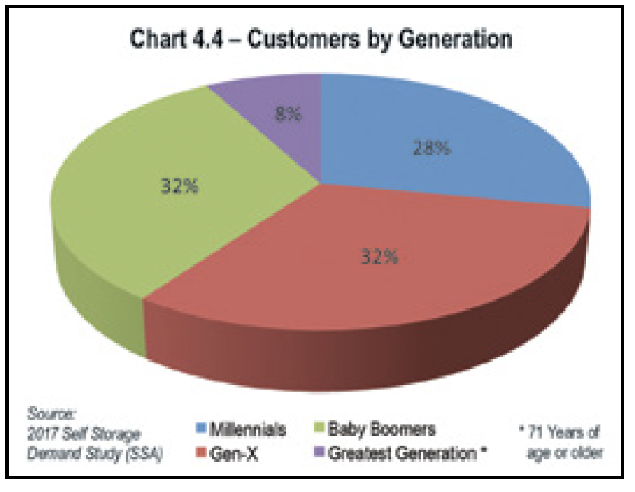

The report indicates that Millennials, also known as Generation Y, are those people who were born just before the new millennium started—somewhere between 1980 and 2000

Generation X are those born between 1965 - 1979. Baby Boomers are those born between 1946 and 1964. The almanac indicates that the Greatest Generation are those of 71 years of age and older and are typically born between 1890 and 1915 as “they grew up during the Great Depression and fought World War II, or those whose labor helped win it.” However, considering that the age (at least 71) and year born are so disparate, I believe this was a mistake that really meant between the years 1890 and *1945.*

The self-storage almanac indicates that Baby boomers and Gen-X renters make up the majority of the self-storage customer base as seen in Chart 4.4 from the almanac, but considering that Boomers are 28% of the customer base (only a 4% difference), I’d argue that it’s actually pretty generationally mixed (with the exception of the Greatest generation).

To explore how America’s use of the self-storage industry was related to their rate of consumption, I needed to find out how much people were actually consuming. I obtained U.S. consumption data from Worldbank.org where I found specifically how that based on household final consumption expenditure[38], in 2017 alone, U.S. consumers spent over $13 trillion, nearly three times as much as the second largest consumer market, China. This is particularly shocking considering that China has the largest population (1.3 billion) in comparison to the the United States which only has 325 million.[39] With so much consumption, it is in some ways not surprising that the self-storage industry has been following and catering to that growth. For my visualization, I created side by side sparklines that emphasize their adjacent trajectory.[40] Final below:

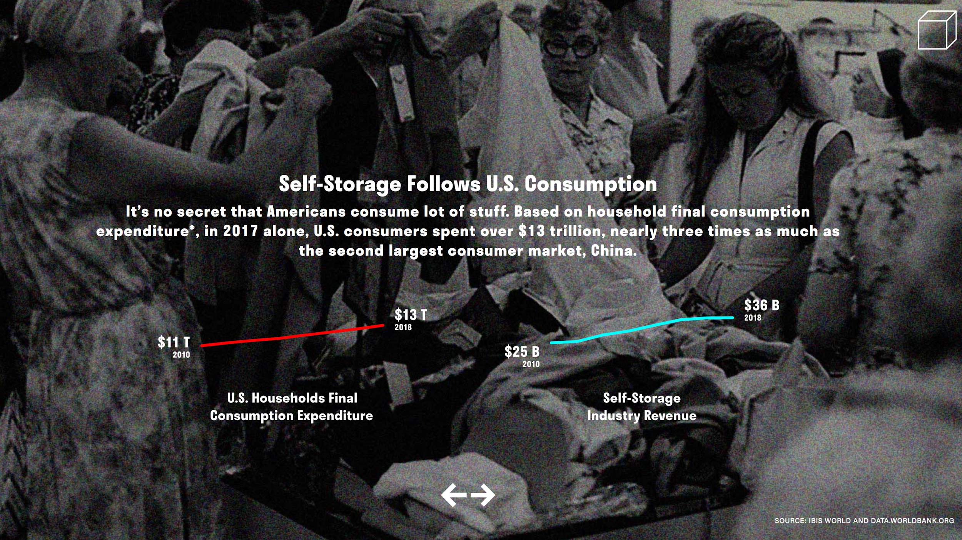

The online self-storage industry publication site, Sparefoot, touts that the industry had over 1.7 billion square feet of rentable self-storage space as of March 2019. Considering that large numbers can be difficult to attain a sense a scale of without comparison, with encouragement of Christian Swineheart, I decided to plot this data on to something more tangible, specifically a city map. Serendipitously, Washington D.C. was not only similar in size at 68.34 square miles (of which 61.05 square miles is land and 7.29 square miles (10.67%) is water[41]) but was also an ideal size because of it square shape. I utilized a number programs in order to create my map of Washington D.C. I first analyzed my data in google sheets and then brought the data into Illustrator and Indesign for svg creation (from there I copied the svg output code placed into my html and jquery code for final display). Using illustrator, I assigned 1 square box to equal 1 square mile and mapping over that a map illustration of D.C. I went through a number of maps for this, as I wanted to ensure I included a map with sufficient identifiable land detail.

For further perspective, I decided to compare the industry to other ubiquitous brands like Starbucks and Mcdonalds,[42] applying the same method mentioned above. I discovered that the total square footage of Starbucks and McDonalds combined were only a fraction of the amount compared to the total square footage of rentable space of the self-storage industry. In my final visualization, I layered that upon the total rentable self-storage space for visual comparison. Below is the final visualization.

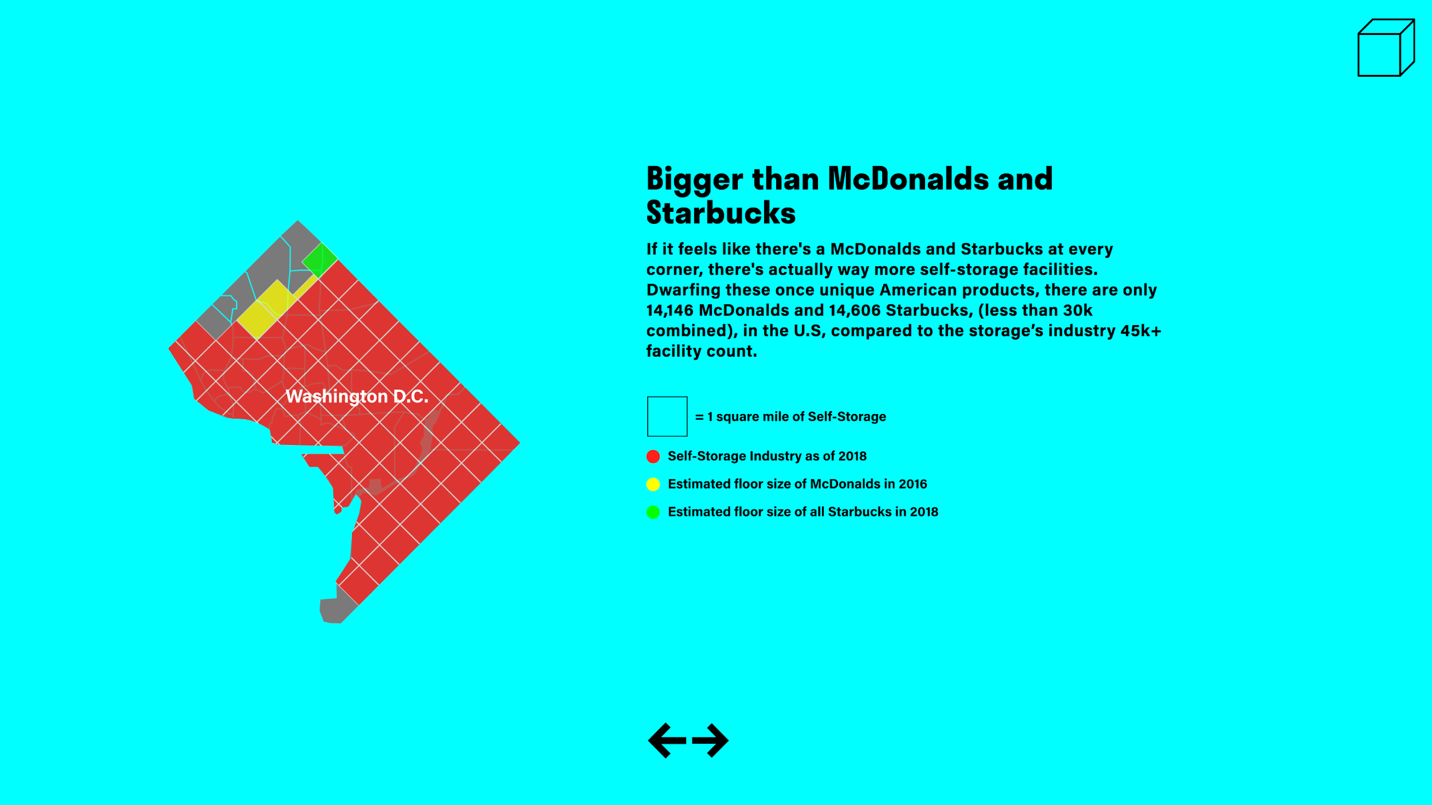

Furthermore, after examining and visualizing the total financial growth (alongside consumerism) and land size of the self-storage industry, I wanted to explore the personal aspects of this product. For this I turned to the survey data mentioned above, for which I made a number of amendments to the survey data for visual clarity. The original data had a total of 19 categories (Table 4.7). I collapsed them into 12 so that visually it would read better and also by category of home materials to avoid repetition of kinds of items.

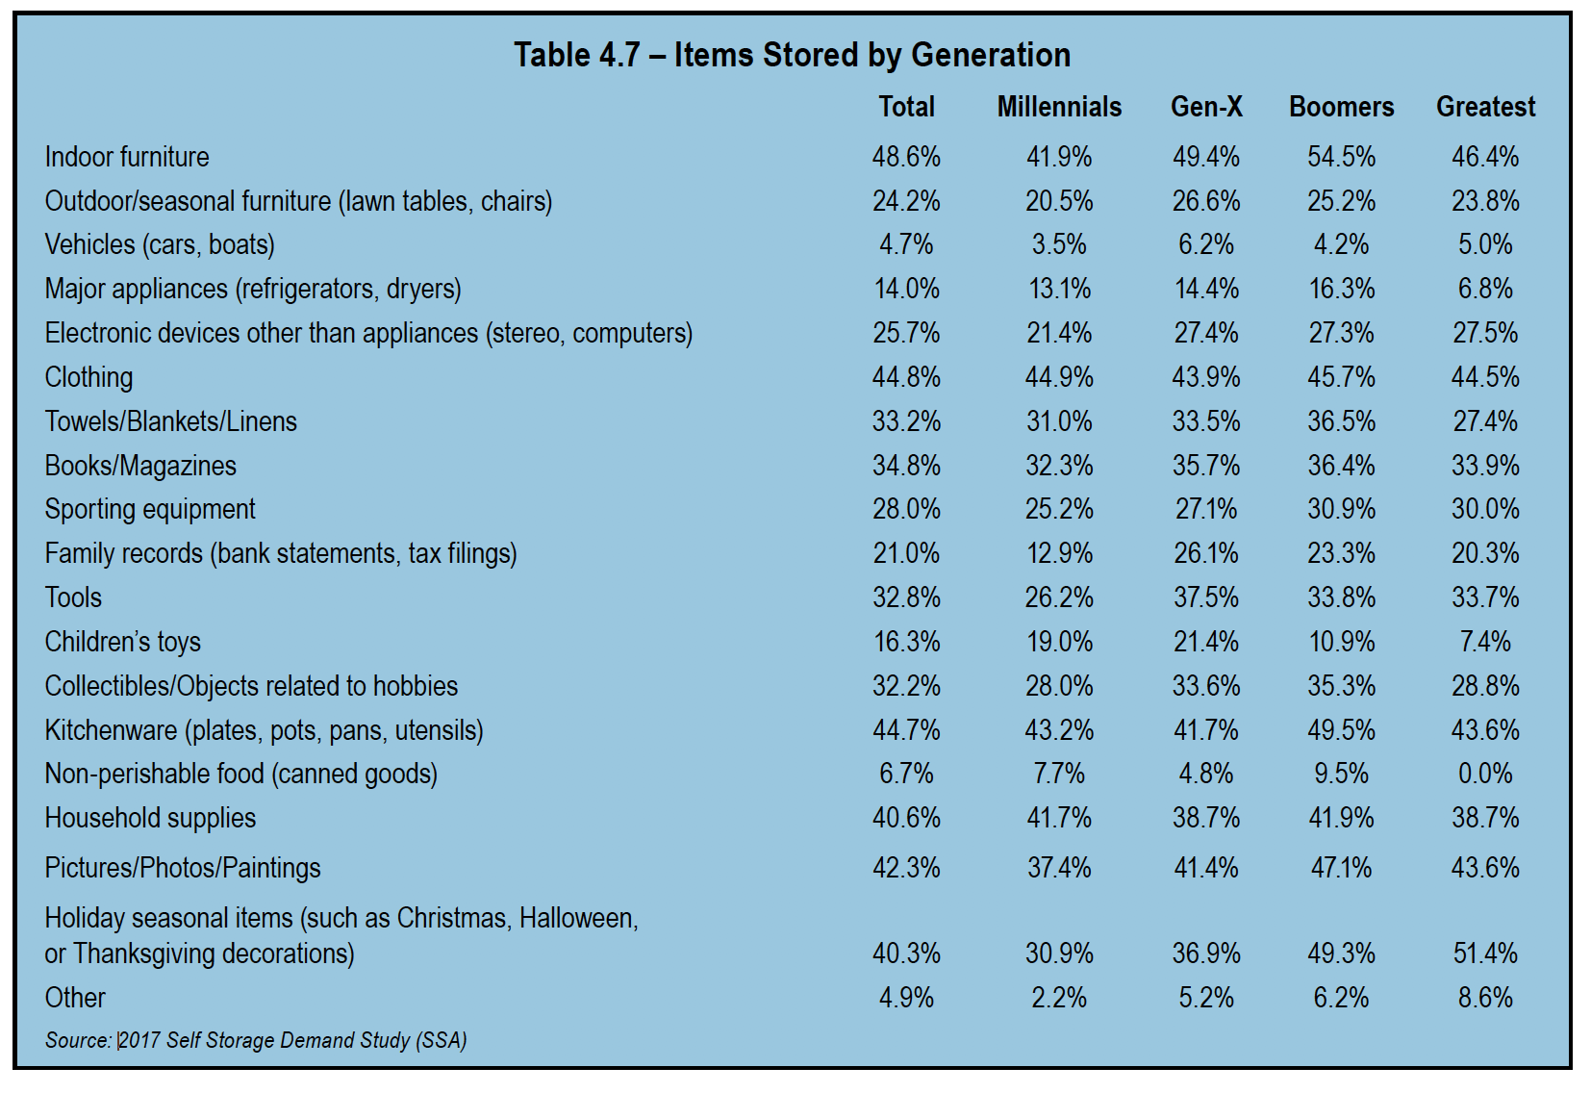

I revised the categories of items stored by generation based on similarity of categories, their use, and areas of which they would be stored at home. My revised breakdown of items stored included the following:

* A new category titled “Houseware” was created where I combined the categories of “Household supplies,” “Kitchenware (plates, pots, pans, utensils)” and “Towels/Blankets/Linens.”
* The “Furniture” category was revised to that it also included both indoor but also “Outdoor/seasonal furniture.”
* A new category titled “Hobby related objects” was created which encompassed “Collectibles/Objects related to hobbies” and “Tools.”
* “Personal items” was revised to include “Pictures/Photos/Paintings” and “Family records (bank statements, tax filings).”
* “Holiday seasonal items” include Christmas, Halloween, or Thanksgiving decorations
* “Other” includes “Non-perishable food” and “Vehicles (cars, boats).”

The survey data revealed that average self-storage customer stored a lot of the same things they already keep at home, suggesting that Americans either have too much stuff or not enough room. Houseware was the largest percentage at 22% which included items like pots, pans, linens, towels, kitchen stuff), followed by furniture at 13.5%, Hobby Related Items at 12%, Personal Items (photos, financial documents) at 11.7%, and Clothing at 8.3%. I discovered a number of insights which I highlighted as captions in my final visualizations. These were: Millennials store the most houseware of all the generations. Gen-X users are among the highest percentage to store furniture. Boomers store the least amount of books and magazines. The Greatest generation store the highest percentage of holiday decorations. Below is my final visualization for this data (this one just showing the total average). I chose squeaky colors to emphasize the scale and the bombastic essence of the self-storage industry. Though the colors for house-ware is much brighter than the rest, perhaps leading one to read it as a larger percentage than its actual existence, I wanted to emphasize this category and how these items were simply the same kind of things found at home. 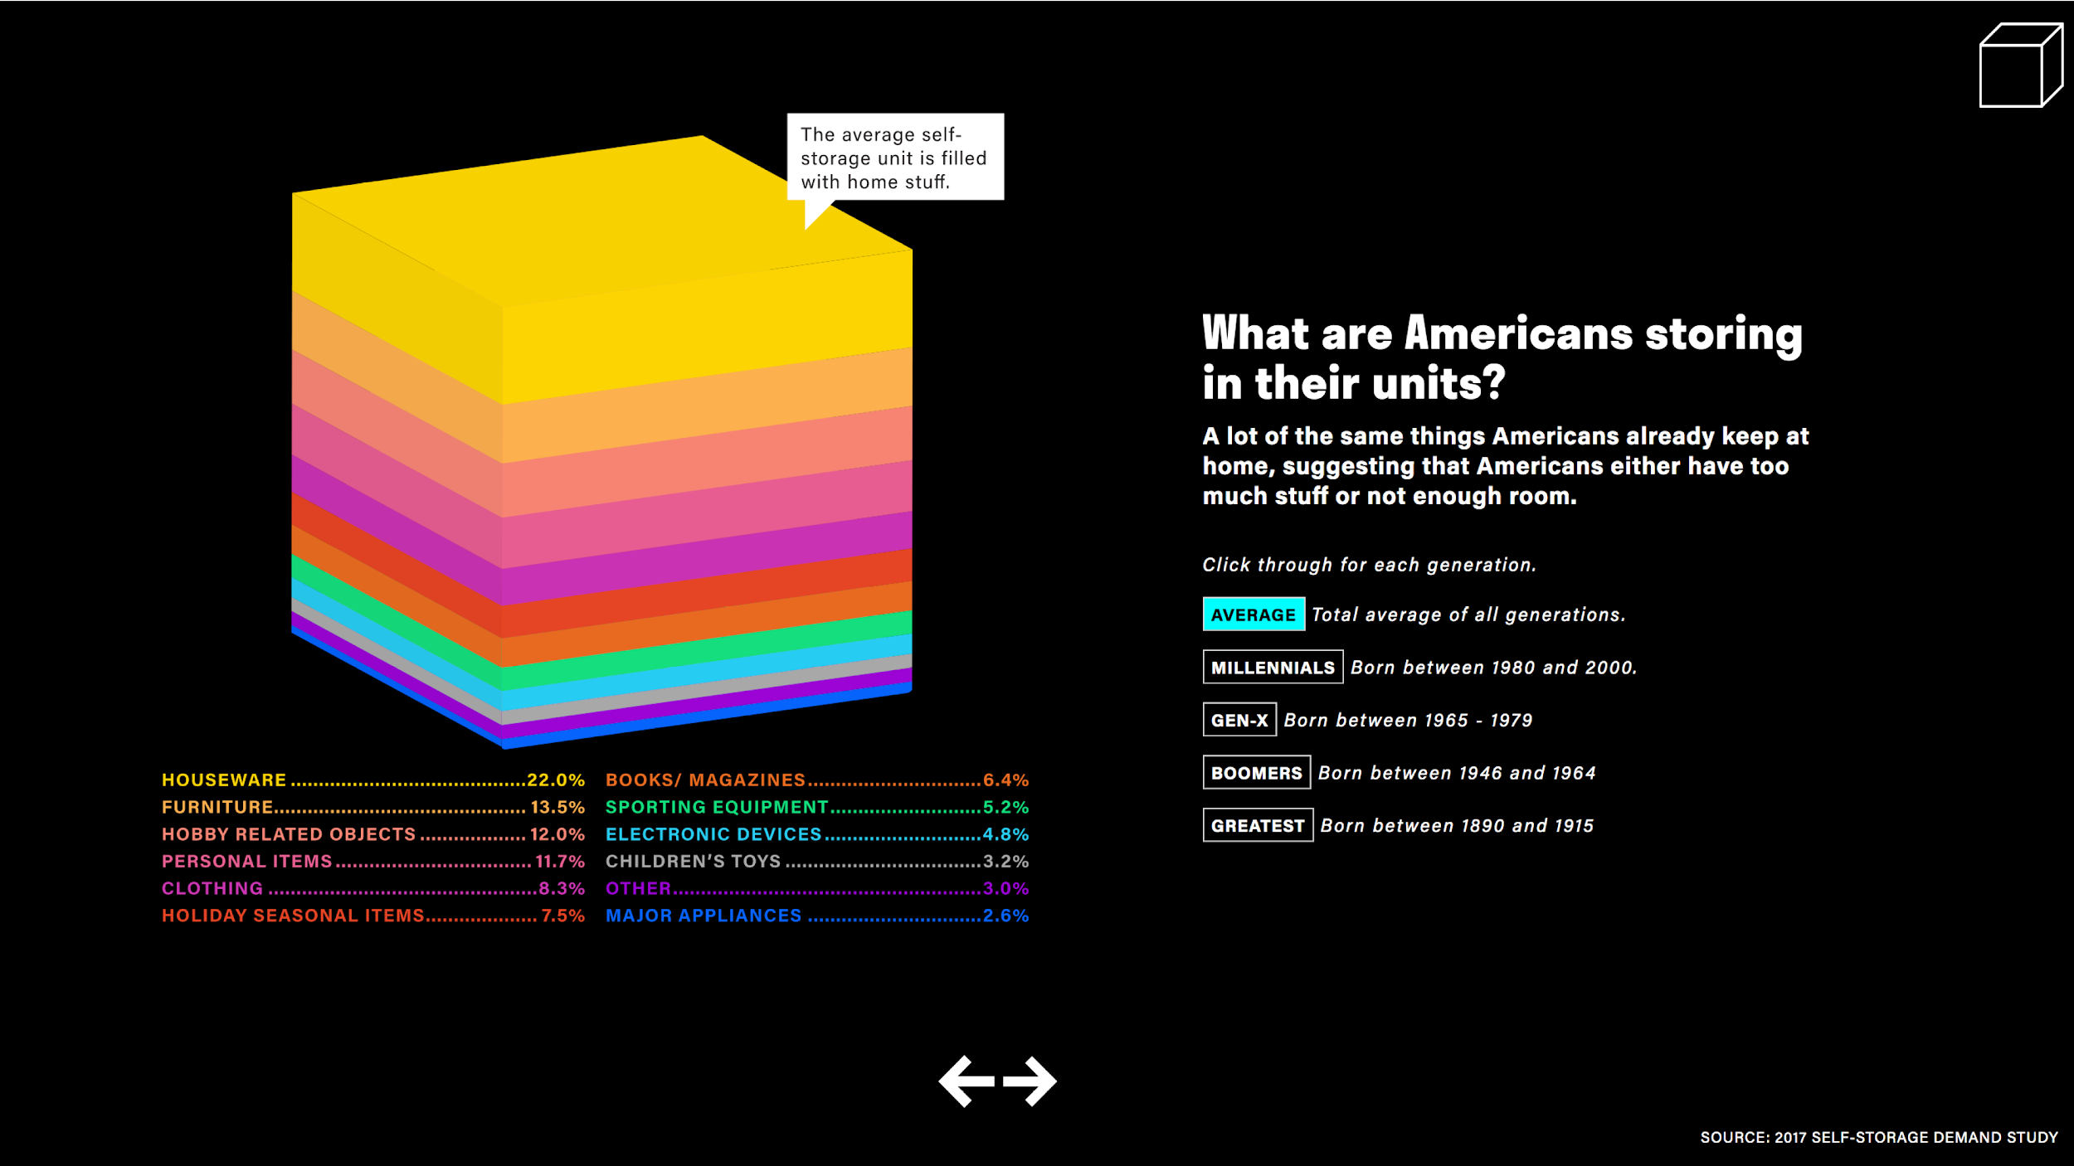

After studying what people were storing, I also wanted to understand the reasons why. For this I used data (Table 4.6) found in the 2019 Self-Storage Almanac. I then brought this data into google sheets for analysis, re-ordered based on top percentages and examined that data based on generation. In addition to listing the generational preferences for storing, this data revealed the range of reasons why people use self-storage correlate to meaningful parts of everyone’s life from family death to a growing family.

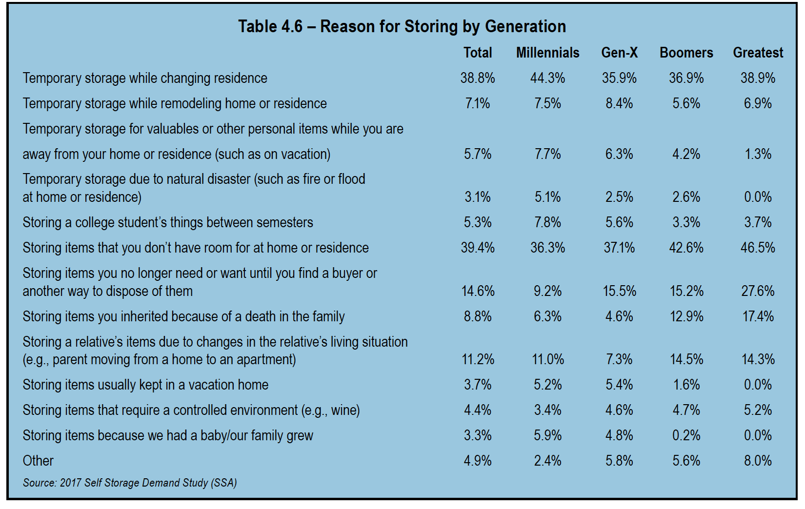

The top reasons are participating in the self-storage industry are that people don’t have enough space at home and as a temporary storage as they change residence. The first reason suggests we are consuming more stuff than we have space and/or our living spaces have shrunken (which is true in the major cities where this industry thrives in).

The second reason suggests that these generations are migrating more, which we see the most with Millennials (44.3%) who are leading generation to use self-storage for this reason suggesting they migrate more than the other generations. Other insights I discovered are that Gen-X uses self-storage the least in the category of “Storing items you inherited because of death in the family,” suggesting they have yet to inherit items and may not need them just yet like millennials. Boomers (46.5%) like the Greatest Generation (42.6%) answered that they use self-storage because they don’t have enough room at their residence. Greatest Generation (27.6) leads in the category of “Storing items you no longer need or want until you find a buyer or another way to dispose them,” suggesting that this generation is holding on to a lot of stuff simply because they don’t know what else to do with them and/or they have more stuff than they know what to do with. Therefore, as this industry survey directly asks Americans how and why they’re dealing with the stuff (which is mostly made of the same personal items they keep at home), it gives us insight into how not only how the self-storage industry is a window into america’s mass consumption, but also representative of it.

However, what I found most interesting about this data were the many reasons Americans turn to self-storage. From death, to a growing family, to natural disaster, to relocation, Americans turn some of their most private possessions into self-storage units during very important parts of their lives. That being said, turning to self-storage costs money, the longer you rent, the higher the costs. Leading me to ask, is this worth it? At least from an economic point of view.

To answer, I needed to know the length of time people are renting. According to the 2017 Self-Storage Demand Study, the average is about 2 years, with half of customers visiting their unit at most only once a month (Chart 6.1, originally from 2019 Self-Storage Almanac). 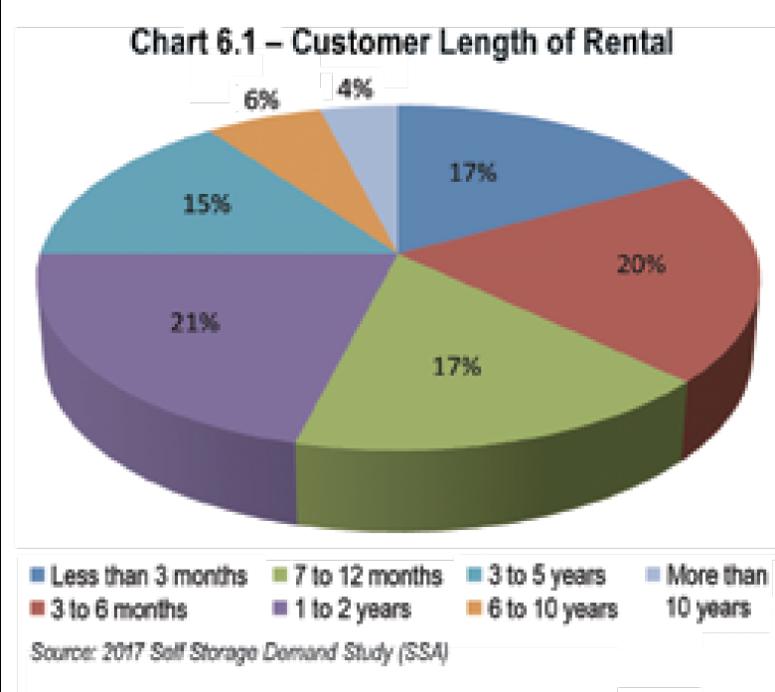

The average monthly cost for self-storage is $88.85.[43] At the 2 year mark, and with the monthly average costs of nearly $90 a month, the average self-storage customer is spending about $2,100 total on their units. Considering that the longer the rental, the higher the accrued costs, renting a self-storage unit can either be reasonable solution or an over-indulgent monthly cost considering how long you rent for and how much your stuff is worth. In order to determine whether this is fiscally prudent, I investigated what a typical self-storage unit would be worth. Considering self-storage is used at a mass scale, using another large ubiquitous retailer that many American used seemed most appropriate for price estimations. Taking the average breakdown of items stored and using big box brands like IKEA and Michaels for estimated pricing, below is how are the calculations of what an average storage unit is worth.[44] Taking the average storage unit contents and the percentage of the items stored, I purposely made very generous estimations, valuing the average storage content worth at $2,000. I characterize these calculations as “generous” considering the average price of a storage unit at auction is $425.[45] However, I intentionally did this because I want to be sensitive to the fact that we tend to ascribe more value to items, simply because they own(ed) them and nostalgic value is very hard to quantify.

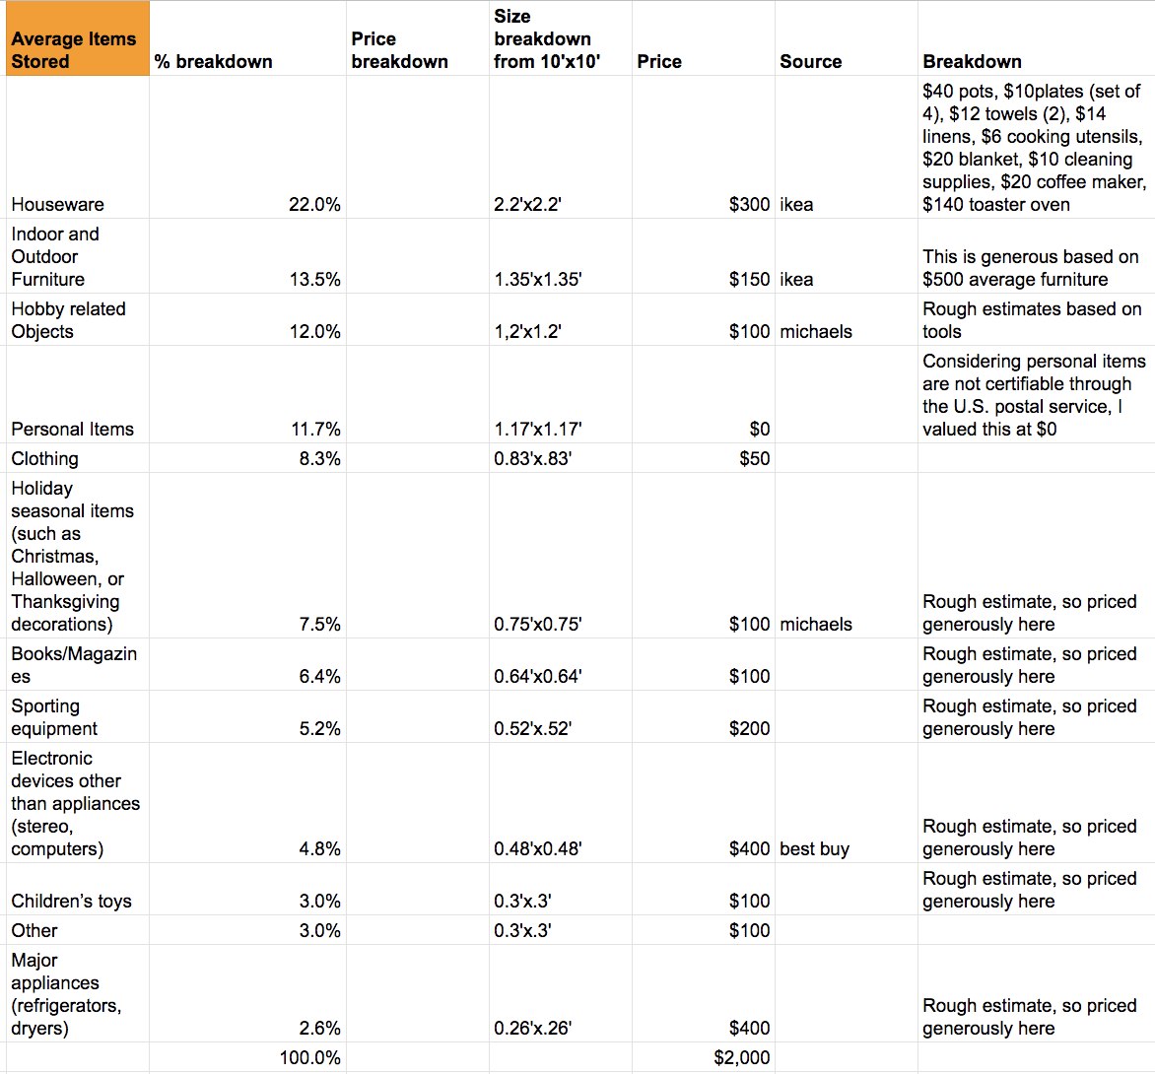

That being said, based on the generous calculations on the previous page, the point of which the average storage unit would start losing money is just below 2 years just barely meeting the price where the average rental cost would accumulate to just above $2,000 ($2,043.55 to be exact). Final visualization below. 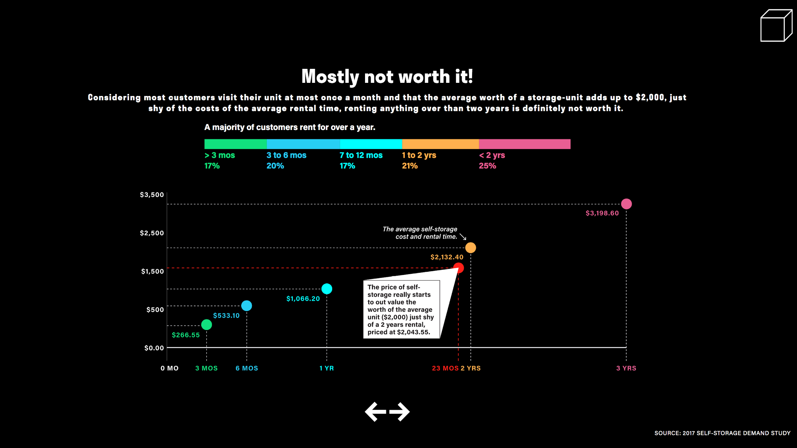

And most customers barely visit their units. Generally, most customers visit their unit at most once a month (chart 6.8 from the Self-Storage Almanac) at 25.7%. 20.4% visited their units only three to six times per year, and 13% reported that they made less than three visits per year. Though considering overall low visitation, it was somewhat surprising to also see that approximately 16% of renters stated that they visit their units about every two weeks, 14 percent visited once a week and 11% of the renters visited their units more than once a week.

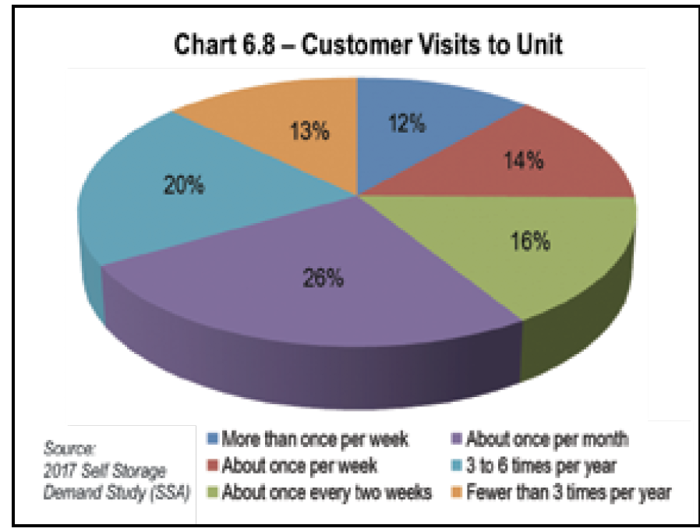

Considering that the estimated average worth of a storage-unit is shy of the costs of the average rental time, renting anything over than two years can be viewed as financially deprecating. Based on this insight, self-storage only seems financially advantageous if used for very short periods of time and not as an extension of one’s home.[46] Though there are exceptions to self-storage unit worth that are depicted on shorts like “Storage Wars,” these are truly exceptions; rarely are such high-priced treasures stored in these units. The typical storage unit has been characterized to be filled with “junk” as by Public Storage Chief Executive, Ronald L. Havner Jr who has been quoted for saying “I’ve sometimes said that we could put a torch to this building and it would have zero effect on the local economy — because that’s how much junk is stored in our properties.”[47] So unless customers are using self-storage for its original intention, a truly temporary space to keep their belongings it can become akin to a gym membership, an often unused added subscription.

**4.2 Project Iterations and Limitations**

I went through a number of wireframe options and prototypes (3 total) before deciding on my final version. Originally, I had intended on making the final site a scroll through experience, then decided on a more click through site, both of which I mocked up prototypes via the program Figma. I am a designer by profession and admitted novice coder so I created most of my final visuals using a combination of design programs (Figma, InDesign, and Illustrator). To create the final svgs, I first cleaned, organized and analyzed my data via google sheets, then brought them to illustrator to create representational graphics. I exported the svgs and copied, cleaned, and input the corresponding svg code into my site to enable interactivity with them using the javascript library jquery and css.

**4.3 Conclusions**

This project aims to provide a window into American consumerism and consumption through studying the very business that caters to it, self-storage. This was done by examining and visualizing industry growth and customer base. To that aim, many aspects of this industry were not fully explored and realized within the timeline of this thesis semester. Aspects I decided to not visualize were how self-storage industry’s expansion also represented e-commerce growth, migration, and population density, how despite industry growth low employee rate stay stable (perhaps representative of America’s AI use of jobs). In addition, global self-storage trends were not explored either. This is partially due to the fact that available data on that was too expensive and researching this otherwise would have taken more time than I had for this project. This would involved taking a(for instance what other countries this industry is growing and how that relates to their respective consumption rates, though there is evidence this is growing fast in China). Neither did I get to visualize the ability to view this industry on a map, though I had state by state industry data that included rentable self-storage square foot data, facility count, average square foot per capita, and population. A map would have revealed a more micro level of how this industry operates in America and further analysis of this sort of data could have gleaned individual state industry insights. However, considering that the large scale of market and industry data, exploring the industry through this sort of lens may have been have been a digression from the main perspective I was aiming to explore with this project and possibly become a regurgitation of the data from industry reports for facility operators that I kept finding. I also didn’t go into the generational breakdown of the survey data regarding number of visits nor the average self-storage unit sizes and their generational breakdowns. My main goal for my visualizations were to provide insight into the average self-storage customers, so I selectively only chose to do generational breakdowns for items stored and reasons why. These include more full explorations into how self-storage is representative of migration and population density (though my data analysis make strong suggestions of this, it is not a full exploration). My final web visualization was ultimately text light, as I wanted to give more emphasis to the visuals, and create a simple and direct approach to the story I was telling. I hope this examination of the self-storage industry provides an in-depth look into a vital aspect of American consumerism.

I personally have never used self-storage myself, but as I am entering new phases of my life (particularly elder care for my parents), I beginning to experience first hand the need for such an outlet. Like millions of others have had the privilege of taking care of people they love and thus their stuff, as I manage my aging parents, and thus their abundant personal belongings, self-storage is looking more and more like a convenient and necessary option. If I do use self-storage I can only hope I will take my own advice, using it for its original intention, temporarily.

As I began to finish the final visualizations for my project, I couldn’t help but think of Marie Kondo, whose Netflix television series inspired my thesis venture into self-storage. Marie Kondo’s organizing philosophy is to first pile of up all of one’s stuff in order to grasp its volume, and then assess the value of the items one by one, only keeping what is necessary and parting with the excess. Millions of Americans are opting for a different version of this ritual: sending their piles to self-storage. Is it worth it? That answer lies really relies its owners. However, as american consumption continues to rises, self-storage does to. And though the American capitalistic ideals tend to always aim to a never-ending top trajectory of growth and revenue, there will be eventually be a tipping point of this. Self-storage will eventually run out of space, and thus renting it may reflect the same housing prices issues we see in major cities where millions are squeezed out due to higher living expenses. And thus a more important question may emerge from is it worth it, to can we afford it?

**References**

Amadea, Kimberly. “Personal Consumption Expenditures, Statistics, and Why It’s Important.” TheBalance.com. <https://www.thebalance.com/personal-consumption-expenditures-3306107> Accessed March 24, 2019.

Ballard, Anne M. “Length of Stay.” Mini-Storage Messenger, December 2018.

Brodesser-Akner, Taffy. “Marie Kondo, Tidying Up and the Ruthless War on Stuff” *The New York Times Magazine*. July 6, 2016. Accessed March 15, 2019. <https://www.nytimes.com/2016/07/10/magazine/marie-kondo-and-the-ruthless-war-on-stuff.html>

Danziger, P. N. (2004). *Why people buy things they don’t need: Understanding and predicting consumer behavior*. Chicago: Dearborn.

"Country Comparison China vs United States Population 2019." Countryeconomy.com. Accessed April 1, 2019. <https://countryeconomy.com/countries/compare/china/usa?sc=XE23>.

Eagon, John. “Guess How Many U.S. Storage Facilities There Are Versus Subway, McDonalds’s and Starbucks” Blog. Sparefoot. May 11, 2015. <https://www.sparefoot.com/self-storage/blog/7775-how-many-storage-facilities-are-in-the-us/>

Fred Economic Research. “Personal Consumption Expenditures” <https://fred.stlouisfed.org/series/PCEND> Accessed March 24, 2019.

Fox, R. W., & Lears, T. J. (1983). *The Culture of consumption in America: Critical essays in American history, 1880-1980*. New York: Pantheon Books.

Harrison, Alexander. “U.S. self-storage industry statistics” News. SpareFoot. March 11, 2019. <https://www.sparefoot.com/self-storage/news/1432-self-storage-industry-statistics/>

Harrison, Alexander. Interview by Grace Martinez. Personal interview. New York, March 15, 2019.

Horowitz, D. (1992). *The morality of spending: Attitudes toward the consumer society in America*, 1875-1940. Chicago: I.R. Dee.

Hu, Winnie. “Self-Storage Offers Space for Stuff. But It Gobbles Up Space.” New York Times. April 13, 2017. https://www.nytimes.com/2017/04/13/nyregion/self-storage-new-york-city.html

Kessler, Sarah. “Decluttering Your Life Is Not Just A Trend—It’s Big Business” *Fast Company*. Sep 2, 2015. Accessed: March 18, 2019.

Lifschutz, M. (2019). *Locked in: Low rental vacancies have paved the way for high demand for storage units.* Storage & Warehouse Leasing in the US. IBISWorld.

Mooallem, Jon. “The Self-Storage Self” *The New York Times Magazine,* Sept. 12, 2009. Accessed March 15, 2019. <https://www.nytimes.com/2009/09/06/magazine/06self-storage-t.html?pagewanted=2&_r=1>

Nonko, Emily. “NYC’s storage industry has crate expectations” *NY Post*. Jan 18, 2019. Accessed March 18, 2019. <https://nypost.com/2018/01/18/nycs-storage-industry-has-crate-expectations/>

2019 Self-Storage Almanac. Phoenix: Mini-Storage Messenger. Published annually.

Shatzer, Erica. Interview by Grace Martinez. Personal interview. New York, March 22, 2019.

Sisson, Patrick. “Self-storage: How warehouses for personal junk became a $38 billion industry” *Curbed*, May 17, 2018. Accessed March 15, 2019. <https://www.curbed.com/2018/3/27/17168088/cheap-storage-warehouse-self-storage-real-estate>

Smith, Adam. (1976). *The theory of moral sentiments*. Oxford: Clarendon Press.

The U.S. Bureau of Economic Analysis. “Personal Consumption Expenditures by State, 2017.” <https://www.bea.gov/news/2018/personal-consumption-expenditures-state-2017> Accessed March 24, 2019

"Washington, D.C." Wikipedia. March 24, 2019. Accessed March 30, 2019. https://en.wikipedia.org/wiki/Washington,_D.C.

Whitehouse, Mark. “Number of the Week: Americans Buy More Stuff They Don’t Need” *The Wall Street Journal*, Apr 23, 2011. Accessed March 15, 2019. <https://blogs.wsj.com/economics/2011/04/23/number-of-the-week-americans-buy-more-stuff-they-dont-need/>

Vanderbilt, Tom. *“Self-Storage Nation.*” Slate.com, July 18, 2005. Accessed, March 20, 2019. <https://slate.com/culture/2005/07/self-storage-in-america.html>

Yardi Matrix. Self Storage Industry Overview & Analysis. Santa Barbara, California, Summer 2017.

1. Please note that this is not suggesting that people who opting to use self-storage are also practicing the Marie Kondo method.
2. This is according to the U.S. Bureau of Economic Analysis.
3. Vanderbilt, Tom. “Self-Storage Nation.” Slate.com, July 18, 2005. Accessed, March 20, 2019. https://slate.com/culture/2005/07/self-storage-in-america.html
4. Durable goods include items like furniture and automobiles. This data is from TheBalance.com, a personal finance company that features experts dedicated to giving financial and business advice. Amadea, Kimberly. “Personal Consumption Expenditures, Statistics, and Why It’s Important.” TheBalance.com. https://www.thebalance.com/personal-consumption-expenditures-3306107Accessed March 24. 2019.
5. Lifschutz, M. (2019). *Locked in: Low rental vacancies have paved the way for high demand for storage units*. Storage & Warehouse Leasing in the US. IbisWorld.
6. Though industry took about a 2 or 3% dip, stealing away from of the long-term customers (900 days+), a strong recovery in 2012 and 2013 the industry quickly recovered and blossomed. This is according to Ballard, Anne M. “Length of Stay.” Mini-Storage Messenger, December 2018. (page 11).
7. Total number of self-storage facilities in Europe as of 2018 according to statista: <https://www.statista.com/statistics/482583/self-storage-estimated-number-of-facilities-in-europe/>
8. Though some believe the first self-storage was created in Omaha, Nebraska in 1891 by Martin and Josh Bekins who created the business to help facilitate the migration of Americans to California in early 20th century. Source: https://www.curbed.com/2018/3/27/17168088/cheap-storage-warehouse-self-storage-real-estate
9. Though the unit eventually closed, the same facility was later re-purchased and renovated a new self-storage unit in 2013. Source: https://www.curbed.com/2018/3/27/17168088/cheap-storage-warehouse-self-storage-real-estate
10. Units vary in space that include rooms, compartments, lockers, containers and outdoor space.
11. The unit sizes for self storage are 5x10, 10x10, 5x5, 10x20, 10x15. Source: Harrison, Alexander. “U.S. self-storage industry statistics” News. SpareFoot. March 11, 2019. https://www.sparefoot.com/self-storage/news/1432-self-storage-industry-statistics/
12. 2018 annual industry revenues slightly vary. Sparefoot, the online marketplace for the self-storage industry reports $38 billion dollars in revenue.
13. Harris, Alexander. “U.S. self-storage industry statistics” News. SpareFoot. March 11, 2019. https://www.sparefoot.com/self-storage/news/1432-self-storage-industry-statistics/
14. IbisWorld defines “establishments” as “the smallest type of accounting unit within an enterprise, an establishment is a single physical location where business is conducted or where services or industrial operations are performed. Multiple establishments under common control make up an enterprise.” It should be noted that Sparefoot estimates that the total number of self-storage facilities is between 45,000 and 52,000.
15. This is based on 2015 numbers of Starbucks and McDonalds. Eagon, John. “Guess How Many U.S. Storage Facilities There Are Versus Subway, McDonalds’s and Starbucks” Blog. Sparefoot. May 11, 2015. https://www.sparefoot.com/self-storage/blog/7775-how-many-storage-facilities-are-in-the-us/
16. Mcdonald’s square footage is based on 2016 estimates of average floor space (Data source for floor space of McDonalds: <https://www.statista.com/statistics/587130/average-floor-space-qrs-us/>) of 4500 times the number of locations in 2016, 14,146 (Data source of total numer of McDonalds in the United States: <https://www.statista.com/statistics/256040/mcdonalds-restaurants-in-north-america/>) which equals 63,657,000. For and Starbucks for footage, I took the the number of average floor space (2014: <https://stories.starbucks.com/stories/2014/three-starbucks-stores-that-inspire-one-of-the-most-creative-people-in-busi/>) and times it by the number of locations (Data source of number of starbucks locations: <https://www.statista.com/statistics/218366/number-of-international-and-us-starbucks-stores/>) which equals 24,830,200.
17. This is from Yardi Matrix, a Santa Barbara, California software company focused on commercial real estate industry applications. Source: Yardi Matrix. Self Storage Industry Overview & Analysis. Santa Barbara, California, Summer 2017.
18. Ibid.
19. The industry employees has grown at an annualized rate of 2.1% since 2013. Employment growth has been able to keep up with the pace of the industry due to advanced technology, reducing the need for on-site staff support.
20. Hu, Winnie. “Self-Storage Offers Space for Stuff. But It Gobbles Up Space.” New York Times. April 13, 2017. https://www.nytimes.com/2017/04/13/nyregion/self-storage-new-york-city.html
21. Hu, Winnie. “Self-Storage Offers Space for Stuff. But It Gobbles Up Space.” New York Times. April 13, 2017. https://www.nytimes.com/2017/04/13/nyregion/self-storage-new-york-city.html
22. Page 19, from the 2019 Self-Storage Almanac, which features recent self-storage industry data, statistics and analysis for self-storage owners, operators, investors, developers and appraisers.
23. Self-Storage Almanac, 2019
24. Harrison, Alexander. Interview by Grace Martinez. Personal interview. New York, March 15, 2019.
25. Lifschutz, M. (2019). Locked in: Low rental vacancies have paved the way for high demand for storage units. Storage & Warehouse Leasing in the US. IBISWorld. PG 10
26. Lifschutz, M. (2019). Locked in: Low rental vacancies have paved the way for high demand for storage units. Storage & Warehouse Leasing in the US. IBISWorld.
27. Lifschutz, M. (2019). Locked in: Low rental vacancies have paved the way for high demand for storage units. Storage & Warehouse Leasing in the US. IBISWorld., page 7.
28. IbisWorld, page 6.
29. IbisWorld, page 8.
30. IbisWorld, page 6.
31. Self-Storage Almanac, 2019
32. This makes sense considering that 52% of the market
33. REITs stand for real estate investment trusts.
34. Millennials were born between 1980 and 2000
35. Self-Storage 2019 Almanac.
36. This is often a cost savings when compared to the price per square foot of self-storage versus the cost per square foot when housing the same items at the business location
37. Fox, R. W., & Lears, T. J. (1983). The Culture of consumption in America: Critical essays in American history, 1880-1980. New York: Pantheon Books. Page XII.
38. Source: https://data.worldbank.org. Household final consumption expenditure (formerly private consumption) is the market value of all goods and services, including durable products (such as cars, washing machines, and home computers), purchased by households. It excludes purchases of dwellings but includes imputed rent for owner-occupied dwellings. It also includes payments and fees to governments to obtain permits and licenses. Here, household consumption expenditure includes the expenditures of nonprofit institutions serving households, even when reported separately by the country. Data are in current U.S. dollars.
39. Source: "Country Comparison China vs United States Population 2019." Countryeconomy.com. Accessed April 1, 2019. https://countryeconomy.com/countries/compare/china/usa?sc=XE23.
40. The analysis was originally done in google sheets and then brought into Illustrator for final svg design.
41. Source: "Washington, D.C." Wikipedia. March 24, 2019. Accessed March 30, 2019. https://en.wikipedia.org/wiki/Washington,_D.C.
42. To do this, I had to take the it is a Mcdonald’s square footage which is based on 2016 estimates of average floor space of 4500 square feet and multiply that by the number of locations in 2016, 14,146 which equals 63,657,000. To attain aggregate Starbucks square footage, I took the the number of average floor space (2014: https://stories.starbucks.com/stories/2014/three-starbucks-stores-that-inspire-one-of-the-most-creative-people-in-busi/) and multiplied it by the number of locations (Data source of number of starbucks locations: https://www.statista.com/statistics/218366/number-of-international-and-us-starbucks-stores/) which equals 24,830,200.
43. Source from Sparefoot.com as of March 2018.
44. This was made in googlesheets, where the bulk of my data analysis was done: <https://docs.google.com/spreadsheets/d/1l2-Iazgyr7omRpMOrjbiEOEQgJOdNdWfUu2InJr2DkM/edit?pli=1#gid=1832707697>.
45. Source: Statistic Brain, https://www.statisticbrain.com/self-storage-industry-statistics/
46. Though it should be noted that many customers do use self-storage due to small living conditions (based on dense city dwellings with pricey living square footage space) and or dislocation due to economic misfortune. These sort of circumstances may make self-storage a cost-worthy endeavor.
47. Source: Mooallem, Jon. “The Self-Storage Self” The New York Times Magazine, Sept. 12, 2009. Accessed March 15, 2019. https://www.nytimes.com/2009/09/06/magazine/06self-storage-t.html?pagewanted=2&_r=1